Integration testing
Integration testing is the second level of the software testing process comes after unit testing. In this testing, units or individual components of the software are tested in a group. The focus of the integration testing level is to expose defects at the time of interaction between integrated components or units.

Unit testing uses modules for testing purpose, and these modules are combined and tested in integration testing. The Software is developed with a number of software modules that are coded by different coders or programmers. The goal of integration testing is to check the correctness of communication among all the modules.
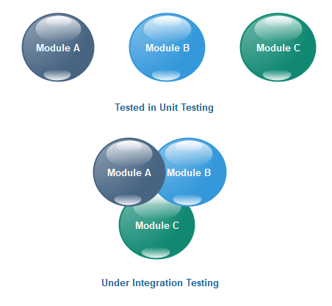
Once all the components or modules are working independently, then we need to check the data flow between the dependent modules is known as integration testing.

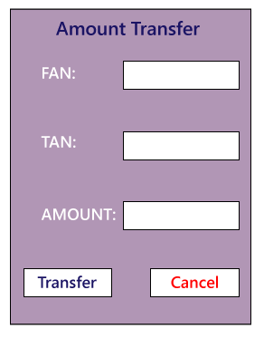
- First, we will login as a user P to amount transfer and send Rs200 amount, the confirmation message should be displayed on the screen as amount transfer successfully. Now logout as P and login as user Q and go to amount balance page and check for a balance in that account = Present balance + Received Balance. Therefore, the integration test is successful.
- Also, we check if the amount of balance has reduced by Rs200 in P user account.
- Click on the transaction, in P and Q, the message should be displayed regarding the data and time of the amount transfer.

Types of Integration Testing
Integration testing can be classified into two parts:
Incremental integration testing
Non-incremental integration testing
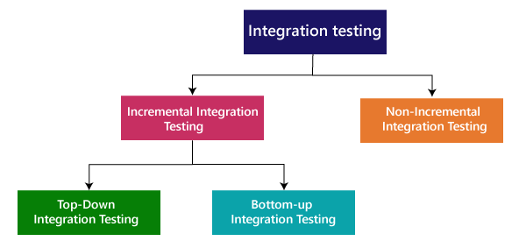
Incremental Approach
In the Incremental Approach, modules are added in ascending order one by one or according to need. The selected modules must be logically related. Generally, two or more than two modules are added and tested to determine the correctness of functions. The process continues until the successful testing of all the modules.
OR
In this type of testing, there is a strong relationship between the dependent modules. Suppose we take two or more modules and verify that the data flow between them is working fine. If it is, then add more modules and test again.

For example: Suppose we have a Flipkart application, we will perform incremental integration testing, and the flow of the application would like this:
Amazon→ Login→ Home → Search→ Add cart→Payment → Logout
Incremental integration testing is carried out by further methods:
Top-Down approach
Bottom-Up approach
Top-Down Approach
The top-down testing strategy deals with the process in which higher level modules are tested with lower level modules until the successful completion of testing of all the modules. Major design flaws can be detected and fixed early because critical modules tested first. In this type of method, we will add the modules incrementally or one by one and check the data flow in the same order.
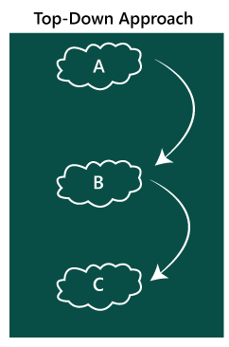
In the top-down approach, we will be ensuring that the module we are adding is the child of the previous one like Child C is a child of Child B and so on as we can see in the below image:
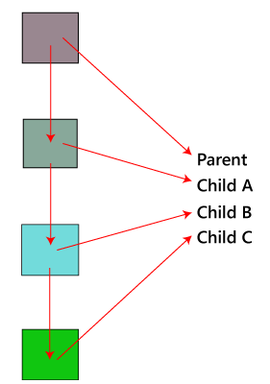
Bottom-Up Method
The bottom to up testing strategy deals with the process in which lower level modules are tested with higher level modules until the successful completion of testing of all the modules. Top level critical modules are tested at last, so it may cause a defect. Or we can say that we will be adding the modules from bottom to the top and check the data flow in the same order.
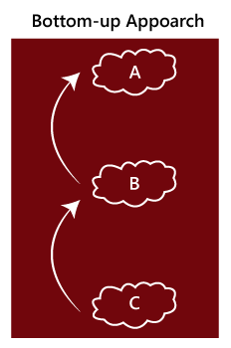
In the bottom-up method, we will ensure that the modules we are adding are the parent of the previous one as we can see in the below image:
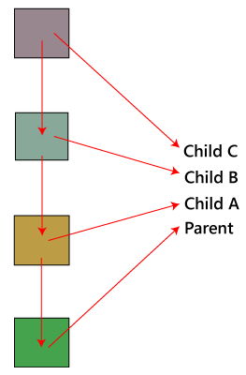
Hybrid Testing Method or Mixed Testing or Sandwich Testing
In this approach, both Top-Down and Bottom-Up approaches are combined for testing. In this process, top-level modules are tested with lower level modules and lower level modules tested with high-level modules simultaneously. There is less possibility of occurrence of defect because each module interface is tested.
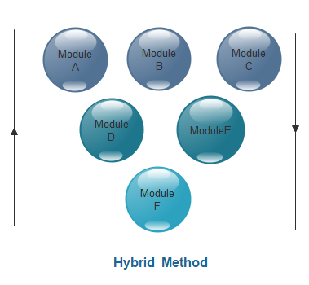

Non- incremental integration testing
We will go for this method, when the data flow is very complex and when it is difficult to find who is a parent and who is a child. And in such case, we will create the data in any module bang on all other existing modules and check if the data is present. Hence, it is also known as the Big bang method.
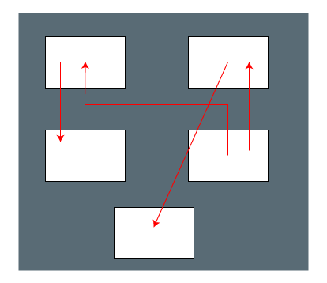

Big Bang Method
The Big Bang Method is an integration testing approach in which all or most individually developed software modules are combined at once and then tested as a complete integrated unit.
In this method, individual modules are usually tested through unit testing before integration. However, instead of integrating modules gradually, the modules are assembled together in a single step.
. Diagram of the Big Bang Method
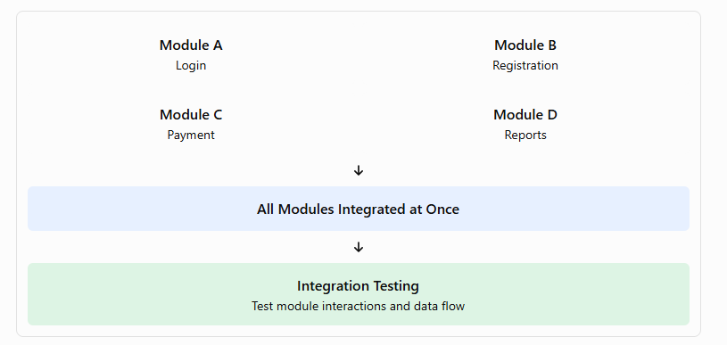
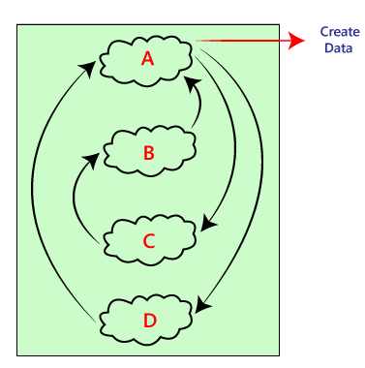

Steps involved
- Develop modules: Develop individual modules independently.
- Perform unit testing: Test each module separately.
- Integrate modules: Combine all or most modules simultaneously.
- Execute integration tests: Test interactions, interfaces, and data exchange.
- Identify defects: Detect failures caused by module interactions.
- Debug and retest: Correct defects and repeat the relevant tests.

Example: College Management System
Consider a college management system containing four modules.
Module | Function
Login | Authenticates users.
Student registration | Stores student details.
Fee payment | Processes fee transactions.
Report generation | Generates student and fee reports.
In the Big Bang Method, all four modules are integrated together after their individual development and unit testing.
The testing team then checks whether:
- Students can log in and register.
- Registration details are stored correctly.
- Fee payments are linked to the correct student.
- Reports display accurate student and payment information.
Big Bang Method vs Incremental Integration Testing
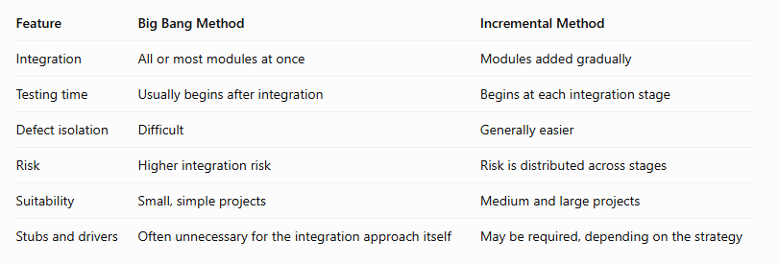
System Testing
System testing is the testing of the complete, integrated software system to evaluate whether it satisfies its specified functional and non-functional requirements.
It examines the software as a whole, rather than testing individual components in isolation.

Objectives
- Verify end-to-end functionality.
- Evaluate interactions between integrated modules.
- Test performance, security, reliability, and usability.
- Check compatibility with operating systems, browsers, and devices.
- Identify failures caused by the complete system configuration.
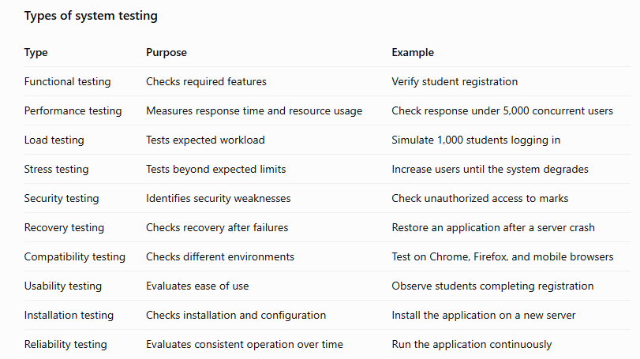

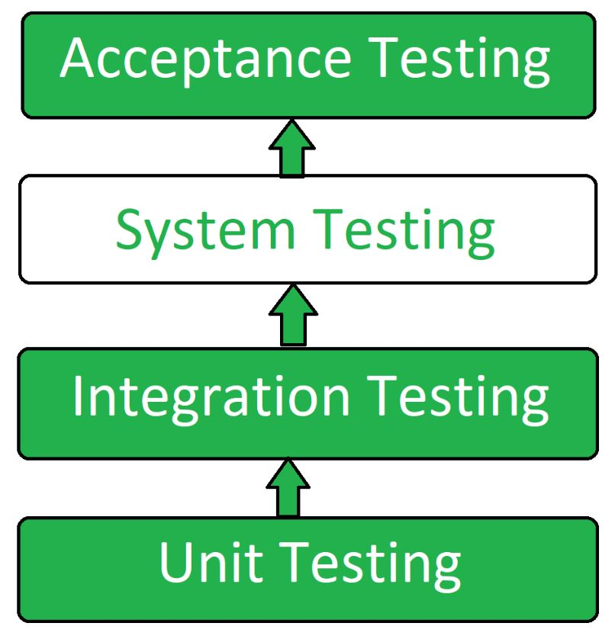

System Testing Process: System Testing is performed in the following steps:

Test Environment Setup: Create testing environment for the better quality testing.
Create Test Case: Generate test case for the testing process.
Create Test Data: Generate the data that is to be tested.
Execute Test Case: After the generation of the test case and the test data, test cases are executed.
Defect Reporting: Defects in the system are detected.
Regression Testing: It is carried out to test the side effects of the testing process.
Log Defects: Defects are fixed in this step.
Retest: If the test is not successful then again test is performed.

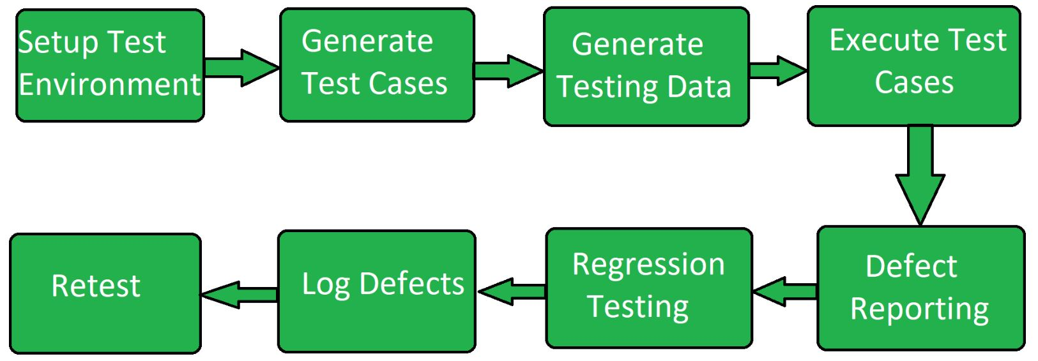

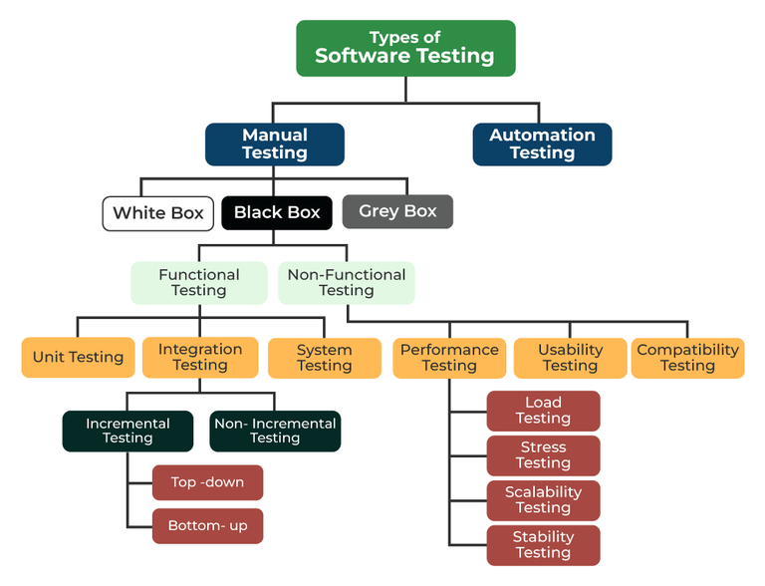

Manual Testing

Definition
Manual testing is the process of executing test cases and verifying software behavior by human testers without using automation to perform the test steps.
The tester supplies inputs, observes the application, compares actual and expected results, and records defects.

Objectives
- Identify functional defects.
- Evaluate usability and user experience.
- Check visual presentation.
- Explore unexpected application behavior.
- Verify user workflows.
- Identify issues that require human judgment.

Types of manual testing
1. Exploratory testing: Testers explore the application and design tests based on what they observe.
2. Usability testing: Evaluates whether the application is easy to learn and use.
3. Ad hoc testing: Informal testing performed without a detailed predefined test-case structure.
4. Acceptance testing: Users or authorized representatives check whether the software satisfies acceptance criteria. Acceptance testing may also be automated.

Advantages
- Low initial setup cost.
- Effective for exploratory testing.
- Suitable for evaluating user experience.
- Allows flexible investigation of unexpected behavior.
- Useful when requirements or interfaces change frequently.

Limitations
- Repetitive tests take time.
- Results can vary between testers.
- Human mistakes may occur.
- Large regression suites are expensive to execute manually.
- It is difficult to repeat large-scale tests frequently.

Automatic (Automated) Testing

Definition
Automated testing uses software tools, scripts, and testing frameworks to execute test cases and compare actual results against expected results automatically or with limited human intervention.
Common tools include Selenium, Playwright, Cypress, JUnit, and pytest.

Objectives
- Reduce repetitive manual work.
- Execute test cases consistently.
- Speed up regression testing.
- Support frequent software releases.
- Test multiple inputs and configurations.
- Integrate testing into continuous integration and deployment pipelines.

Types of automated testing
1. Unit-test automation: Automatically tests individual functions, methods, or classes.
2. API-test automation: Sends requests to application interfaces and checks responses.
3. UI-test automation: Simulates user interactions with web or desktop interfaces.
4. Regression-test automation: Re-executes existing tests after software changes.
5. Performance-test automation: Generates workloads and measures response time, throughput, and resource usage.

Advantages
- Fast execution of repeated tests.
- Consistent test execution.
- Suitable for large regression suites.
- Supports frequent builds and releases.
- Can test many data combinations.
- Produces repeatable test results and reports.

Limitations
- Initial setup can be expensive.
- Scripts require maintenance.
- Poorly designed tests can become unreliable.
- Some visual and usability problems require human judgment.
- Automation cannot guarantee that all defects will be detected.
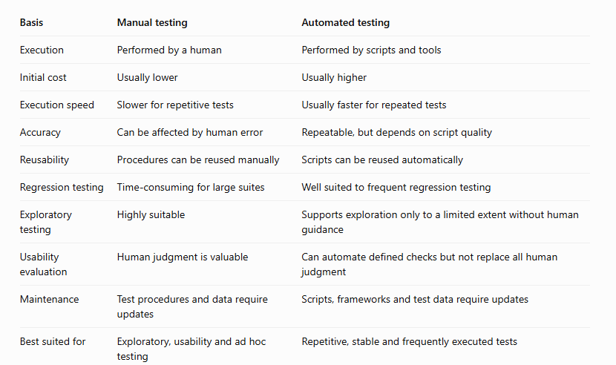

White Box Testing
White-box testing is a software testing technique in which the internal structure, source code, logic, control flow, and execution paths of a program are examined to identify defects.
It is also known as structural testing, glass-box testing, or clear-box testing.
In white-box testing, the tester has knowledge of the program's internal implementation.

Objectives
- Verify the correctness of internal program logic.
- Test statements, branches, conditions, and execution paths.
- Identify logical errors and unreachable code.
- Check loops and exception-handling mechanisms.
- Measure code coverage.
- Identify potential security and data-flow defects.
The box testing approach of software testing consists of black box testing and white box testing. We are discussing here white box testing which also known as glass box is testing, structural testing, clear box testing, open box testing and transparent box testing. It tests internal coding and infrastructure of a software focus on checking of predefined inputs against expected and desired outputs. It is based on inner workings of an application and revolves around internal structure testing. In this type of testing programming skills are required to design test cases. The primary goal of white box testing is to focus on the flow of inputs and outputs through the software and strengthening the security of the software.
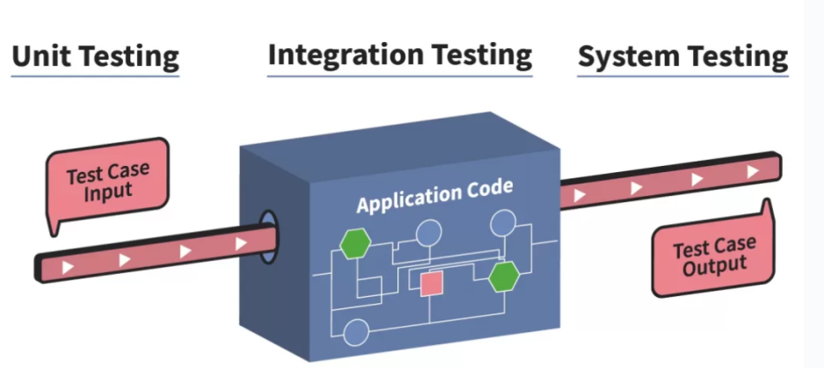
The term 'white box' is used because of the internal perspective of the system. The clear box or white box or transparent box name denote the ability to see through the software's outer shell into its inner workings.
Developers do white box testing. In this, the developer will test every line of the code of the program. The developers perform the White-box testing and then send the application or the software to the testing team, where they will perform the black box testing and verify the application along with the requirements and identify the bugs and sends it to the developer.
The developer fixes the bugs and does one round of white box testing and sends it to the testing team. Here, fixing the bugs implies that the bug is deleted, and the particular feature is working fine on the application.
The white box testing contains various tests, which are as follows:
- Path testing
- Loop testing
- Condition testing
- Testing based on the memory perspective
- Test performance of the program

Path testing

Path testing attempts to execute different control-flow paths in the program.
It is useful for identifying defects in complex decision-making logic. Testing every possible path may be impractical when loops or many conditions are present.

In the path testing, we will write the flow graphs and test all independent paths. Here writing the flow graph implies that flow graphs are representing the flow of the program and also show how every program is added with one another as we can see in the below image:
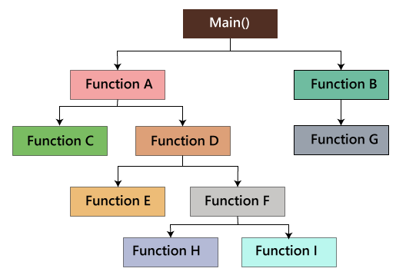

And test all the independent paths implies that suppose a path from main() to function G, first set the parameters and test if the program is correct in that particular path, and in the same way test all other paths and fix the bugs.

Loop testing
In the loop testing, we will test the loops such as while, for, and do-while, etc. and also check for ending condition if working correctly and if the size of the conditions is enough.
For example: we have one program where the developers have given about 50,000 loops.
while(50,000)
{
……
……
}
We cannot test this program manually for all the 50,000 loops cycle. So we write a small program that helps for all 50,000 cycles, as we can see in the below program, that test P is written in the similar language as the source code program, and this is known as a Unit test. And it is written by the developers only.

Test P
{
……
…… }

As we can see in the below image that, we have various requirements such as 1, 2, 3, 4. And then, the developer writes the programs such as program 1,2,3,4 for the parallel conditions. Here the application contains the 100s line of codes.

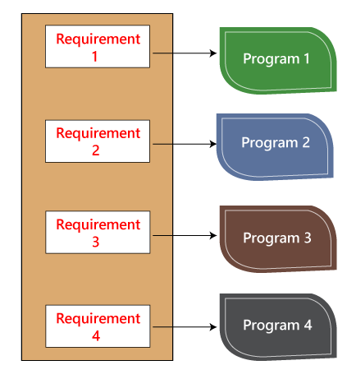
The developer will do the white box testing, and they will test all the five programs line by line of code to find the bug. If they found any bug in any of the programs, they will correct it. And they again have to test the system then this process contains lots of time and effort and slows down the product release time.
Now, suppose we have another case, where the clients want to modify the requirements, then the developer will do the required changes and test all four program again, which take lots of time and efforts.
These issues can be resolved in the following ways:
In this, we will write test for a similar program where the developer writes these test code in the related language as the source code. Then they execute these test code, which is also known as unit test programs. These test programs linked to the main program and implemented as programs.
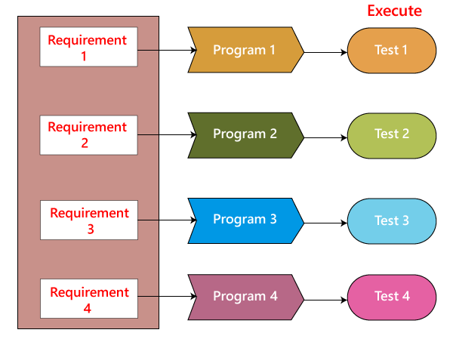
Therefore, if there is any requirement of modification or bug in the code, then the developer makes the adjustment both in the main program and the test program and then executes the test program.

Condition testing
In this, we will test all logical conditions for both true and false values; that is, we will verify for both if and else condition.
For example:
- if(condition) - true
- {
- …..
- ……
- ……
- }
- else - false
- {
- …..
- ……
- ……
- }
The above program will work fine for both the conditions, which means that if the condition is accurate, and then else should be false and conversely.

Testing based on the memory (size) perspective
The size of the code is increasing for the following reasons:
- The reuse of code is not there: let us take one example, where we have four programs of the same application, and the first ten lines of the program are similar. We can write these ten lines as a discrete function, and it should be accessible by the above four programs as well. And also, if any bug is there, we can modify the line of code in the function rather than the entire code.
- The developers use the logic that might be modified. If one programmer writes code and the file size is up to 250kb, then another programmer could write a similar code using the different logic, and the file size is up to 100kb.
- The developer declares so many functions and variables that might never be used in any portion of the code. Therefore, the size of the program will increase.

Test the performance (Speed, response time) of the program
The application could be slow for the following reasons:
- When logic is used.
- For the conditional cases, we will use or & and adequately.
- Switch case, which means we cannot use nested if, instead of using a switch case.
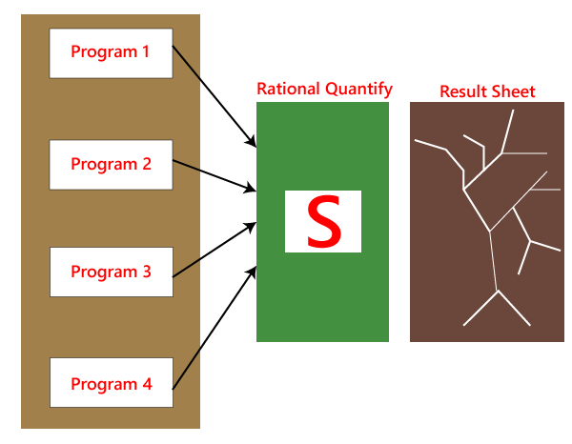
As we know that the developer is performing white box testing, they understand that the code is running slow, or the performance of the program is also getting deliberate. And the developer cannot go manually over the program and verify which line of the code is slowing the program.
To recover with this condition, we have a tool called Rational Quantify, which resolves these kinds of issues automatically. Once the entire code is ready, the rational quantify tool will go through the code and execute it. And we can see the outcome in the result sheet in the form of thick and thin lines.
Here, the thick line specifies which section of code is time-consuming. When we double-click on the thick line, the tool will take us to that line or piece of code automatically, which is also displayed in a different color. We can change that code and again and use this tool. When the order of lines is all thin, we know that the presentation of the program has enhanced. And the developers will perform the white box testing automatically because it saves time rather than performing manually.
Test cases for white box testing are derived from the design phase of the software development lifecycle. Data flow testing, control flow testing, path testing, branch testing, statement and decision coverage all these techniques used by white box testing as a guideline to create an error-free software.

Advantages of White box testing
- White box testing optimizes code so hidden errors can be identified.
- Test cases of white box testing can be easily automated.
- This testing is more thorough than other testing approaches as it covers all code paths.
- It can be started in the SDLC phase even without GUI.

Disadvantages of White box testing
- White box testing is too much time consuming when it comes to large-scale programming applications.
- White box testing is much expensive and complex.
- It can lead to production error because it is not detailed by the developers.
- White box testing needs professional programmers who have a detailed knowledge and understanding of programming language and implementation.

Black box testing
Black-box testing is a software testing technique in which the functionality of an application is tested by providing inputs and examining outputs without requiring knowledge of its internal source code.
It focuses on whether the software behaves according to its requirements.
The tester treats the software as a black box.

Objectives
- Verify functional requirements.
- Check whether correct outputs are produced for given inputs.
- Identify missing functionality.
- Test input validation and error messages.
- Verify boundary conditions.
- Evaluate application behavior from the user's perspective.

Black-box testing is a type of software testing in which the tester is not concerned with the internal knowledge or implementation details of the software but rather focuses on validating the functionality based on the provided specifications or requirements.

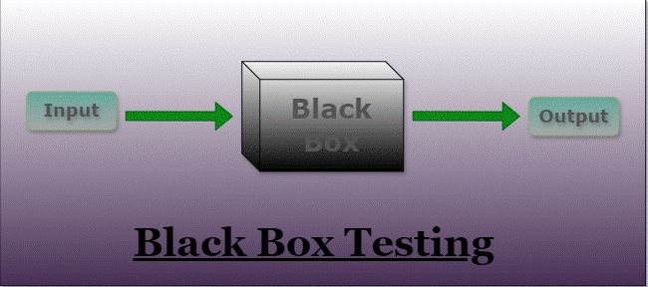

Types Of Black Box Testing
The following are the several categories of black box testing:
- Functional Testing
- Regression Testing
- Nonfunctional Testing (NFT)

Functional Testing:
Functional testing is defined as a type of testing that verifies that each function of the software application works in conformance with the requirement and specification. This testing is not concerned with the source code of the application. Each functionality of the software application is tested by providing appropriate test input, expecting the output, and comparing the actual output with the expected output. This testing focuses on checking the user interface, APIs, database, security, client or server application, and functionality of the Application Under Test. Functional testing can be manual or automated. It determines the system’s software functional requirements.

Regression Testing:
Regression Testing is the process of testing the modified parts of the code and the parts that might get affected due to the modifications to ensure that no new errors have been introduced in the software after the modifications have been made. Regression means the return of something and in the software field, it refers to the return of a bug. It ensures that the newly added code is compatible with the existing code. In other words, a new software update has no impact on the functionality of the software. This is carried out after a system maintenance operation and upgrades.

Nonfunctional Testing:
Non-functional testing is a software testing technique that checks the non-functional attributes of the system. Non-functional testing is defined as a type of software testing to check non-functional aspects of a software application. It is designed to test the readiness of a system as per nonfunctional parameters which are never addressed by functional testing. Non-functional testing is as important as functional testing. Non-functional testing is also known as NFT. This testing is not functional testing of software. It focuses on the software’s performance, usability, and scalability.
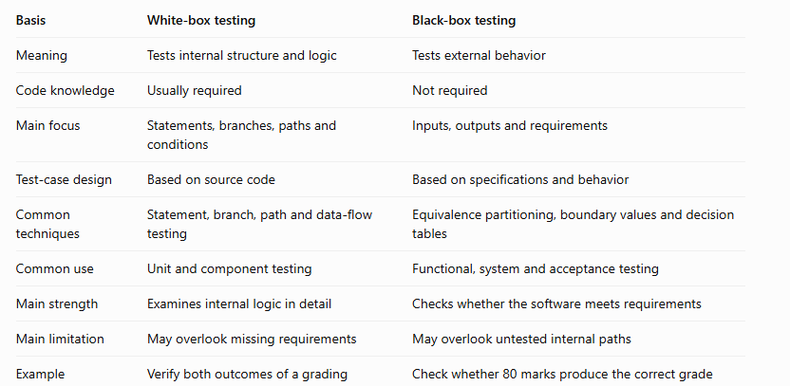

Acceptance Testing
Alpha testing and beta testing are types of acceptance-oriented software testing performed before a software product is released widely to users. They help identify defects, evaluate usability, and determine whether the software is ready for release.
+
Alpha Testing:


1. Alpha Testing
Definition: Alpha testing is a type of acceptance testing performed at the developer's site or within the development organization to identify defects before the software is released to external users.

Objectives
- Identify defects before public release.
- Verify major software functionalities.
- Check usability and reliability.
- Obtain feedback from internal testers.
- Ensure the product is sufficiently stable for beta testing.
Alpha testing is conducted in the organization and tested by a representative group of end-users at the developer's side and sometimes by an independent team of testers.
Alpha testing is simulated or real operational testing at an in-house site. It comes after the unit testing, integration testing, etc. Alpha testing used after all the testing are executed.
It can be a white box, or Black-box testing depends on the requirements - particular lab environment and simulation of the actual environment required for this testing.
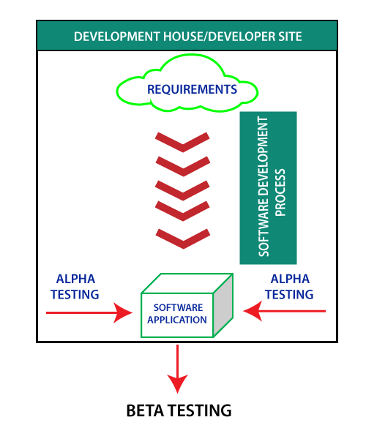
alpha testing process:
- Requirement Review: Review the design of the specification and functional requirement
- Test Development: Test development is base on the outcome of the requirement review. Develop the test cases and test plan.
- Test case design: Execute the test plan and test cases.
- Logging Defects: Logging the identified and detected bug found in the application.
- Bug Fixation: When all the bugs are identified and logged, then there is a need to fix the bug.
- Retesting: When all the issues are solved, and fixed retesting is done.
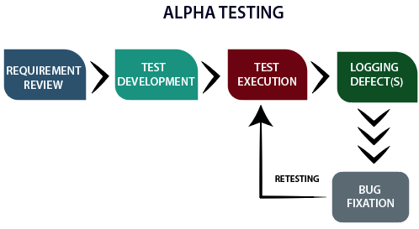
phases of alpha testing:
Alpha testing ensures that the software performs flawlessly and does not impact the reputation of the organization; the company implements final testing in the form of alpha testing. This testing executed into two phases.
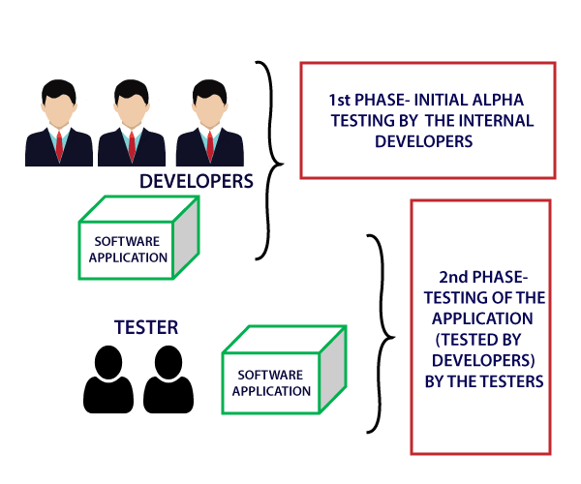
There are two phases of alpha testing.
First Phase: In-house developers of software engineers do the first phase of testing. In this phase, the tester used hardware debugger or hardware aided debugger to catches the bugs quickly. During the alpha testing, a tester finds a lot of bugs, crashes, missing features, and docs.
Second Phase: The second phase involves the quality assurance staff performs the alpha testing by involving black box and white box techniques.
When to perform alpha testing?
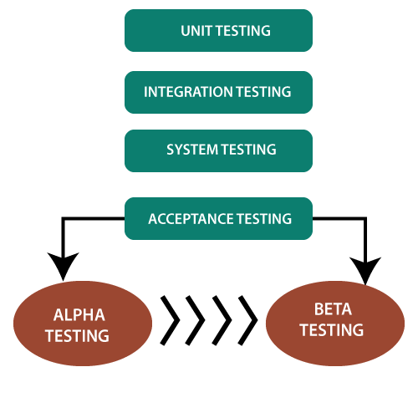
Alpha testing is user acceptance testing. Alpha testing performed once the product has gone through stages of testing and prepared for release. It is executing before beta testing, which is also a part of acceptance testing and can define as field testing. During this testing, we can make changes in the software to improve its quality and functionality. Alpha testing done from the developer's site where independent developers can monitor and record user experience and make necessary changes to enhance the performance.
features of Alpha Testing
- Alpha testing is a type of acceptance testing.
- Alpha testing is happening at the stage of the completion of the software product.
- Alpha testing is in the labs where we provide a specific and controlled environment.
- Alpha testing is in-house testing, which is performed by the internal developers and testers within the organization.
- There is not any involvement of the public.
- Alpha testing helps to gain confidence in the user acceptance of the software product.
- With the help of black box and white box technique, we can achieve the alpha testing.
- Alpha testing ensures the maximum possible quality of the software before releasing it to market or client for beta testing.
- Developers perform alpha testing at developer's site; it enables the developer to record the error with the ease to resolve found bugs quickly.
- Alpha testing is doing after the unit testing, integration testing, system testing but before the beta testing.
- Alpha testing is for testing the software application, products, and projects.

Example
A college develops a new student attendance management system. Before providing it to faculty members for wider use, the development team tests login, attendance entry, percentage calculations, and report generation in its internal test environment.
If the system calculates attendance incorrectly, the team fixes the defect before external testing.

Advantages
- Finds defects before external release.
- Allows close monitoring by the development team.
- Makes it easier to investigate and fix defects.
- Helps assess whether the product is ready for external evaluation.

Limitations
- Internal testers may not represent all real users.
- The test environment may differ from actual usage environments.
- Some real-world usability problems may remain undetected.

Beta Testing

Beta testing is a type of acceptance-oriented testing in which a pre-release version of software is provided to selected external users so they can use it in real or realistic environments and provide feedback.

Objectives
- Collect feedback from actual users.
- Identify defects that internal testing missed.
- Evaluate usability and compatibility.
- Assess behavior under real-world conditions.
- Improve software before general release.
Beta testing is a type of User Acceptance Testing among the most crucial testing, which performed before the release of the software. Beta Testing is a type of Field Test. This testing performs at the end of the software testing life cycle. This type of testing can be considered as external user acceptance testing. It is a type of salient testing. Real users perform this testing. This testing executed after the alpha testing. In this the new version, beta testing is released to a limited audience to check the accessibility, usability, and functionality, and more.
- Beta testing is the last phase of the testing, which is carried out at the client's or customer's site.
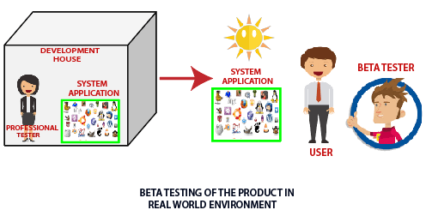

features of beta testing
- Beta testing used in a real environment at the user's site. Beta testing helps in providing the actual position of the quality.
- Testing performed by the client, stakeholder, and end-user.
- Beta testing always is done after the alpha testing, and before releasing it into the market.
- Beta testing is black-box testing.
- Beta testing performs in the absence of tester and the presence of real users
- Beta testing is performed after alpha testing and before the release of the final product.
- Beta testing generally is done for testing software products like utilities, operating systems, and applications, etc.

Beta version of the software:
1) Closed beta version: Closed beta version, also known as a private beta, it is released to a group of selected and invited people. Those people will test the software and evaluate their features and specifications. This beta version represents the software which is capable of delivering value, but it is not ready to be used by everyone. Because it shows the issues like lack of documentation or missing vital features.

2)Open beta version: Open beta is also known as a public beta. The open beta opened to the public. Any user as a tester can assess the beta version to provide the relevant feedback and reviews. Open beta version improves the quality of the final release. This version helps to find the various undetected errors and issues.
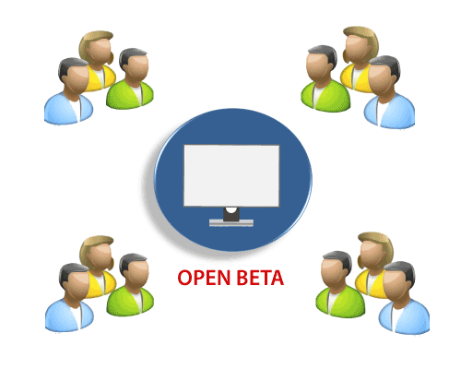
Lifecycle of Beta Testing:
- Planning: Like another testing process, beta testing also supports proper planning. In this stage, the team prepares a testing strategy and defines the goal of testing. In this case, the team establishes the need of users for testing, duration, and necessary details related to the process.
- Participant Recruitment: This is the second stage of the beta process in which the team recruits a group of selected end-users for testing. This group can change as per the requirement of the organization and the product.
- Product Launch: When a team of users (testers) recruited. The beta version of the product is launched or installed at the client or user side, and users will test the product for quality assurance.
- Collect and Evaluate Feedback: When the testing finished, developers will collect the feedback provided by the testers and evaluate it. In the end, based on the feedback, issues, and bugs are fixed and resolved by the responsible individual team.
- Closure: When all the problems fixed and the organization meets the exit criteria, beta testing achieved, and the rewards offered to the testing team.

Types of beta testing:
- Open Beta Testing: Open beta testing involves testing the software product by a large number of people before the final release. The organization decides to make a software product open to the public before releasing the product. Open Beta includes the extensive participation of the public to use and evaluate software product accordingly.
Users report the bug to the organization, along with a suggestion to improve the quality of the software.
- Closed Beta Testing: Opposite to the open beta testing. Closed beta testing performed by the selective and limited number of persons. The organization recruits these. In this testing software product is not open to the public.
- Traditional Beta Testing: In this testing, a software product delivered to the target market, and the feedback from the users collected. This type of testing assistance the beta testing, the quality of the software is improved, and developers can make the changes.
- Public Beta Testing: This type of testing is similar to open testing. Public beta testing also allows the product is delivering to the end-users worldwide, with the aid of various online channels available in the world. From this, the feedback and evaluated data also collected and based on the requirement changes, and the development team implements modifications.
- Technical Beta Testing: Technical beta testing is also an essential type of beta testing. This testing involves delivering the software product to the internal groups of the organization. However, the data and feedback provided by the employees of the organization.
- Focused Beta Testing: This type of testing focused on monitoring and evaluating a specific feature or component of the software. In focused beta testing, the software released to the market and user's experience assessed and collected to make the required changes.
- Post-Release Beta Testing: In this testing, the product delivered to the market for the use of the end-users. Their feedback, reactions, and experience are collect for the future release of the software.
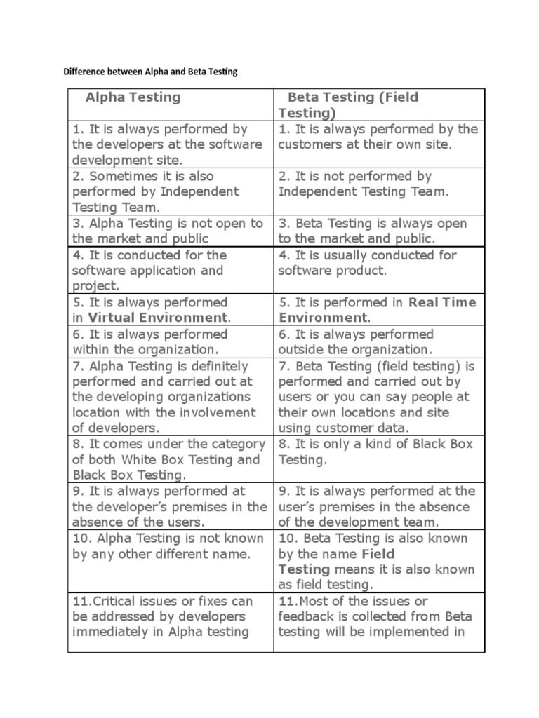
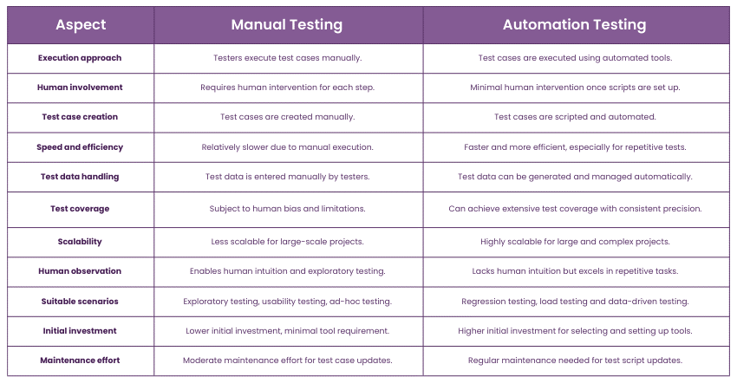

What is Software Quality?
Software quality is defined as a field of study and practice that describes the desirable attributes of software products. There are two main approaches to software quality: defect management and quality attributes.

Software Quality Defect Management Approach
A software defect can be regarded as any failure to address end-user requirements. Common defects include missed or misunderstood requirements and errors in design, functional logic, data relationships, process timing, validity checking, and coding errors.
The software defect management approach is based on counting and managing defects. Defects are commonly categorized by severity, and the numbers in each category are used for planning. More mature software development organizations use tools, such as defect leakage matrices (for counting the numbers of defects that pass through development phases prior to detection) and control charts, to measure and improve development process capability.

Software Quality Attributes Approach
This approach to software quality is best exemplified by fixed quality models, such as ISO/IEC 25010:2011. This standard describes a hierarchy of eight quality characteristics, each composed of sub-characteristics:
- Functional suitability
- Reliability
- Operability
- Performance efficiency
- Security
- Compatibility
- Maintainability
- Transferability
ISO/IEC 25010:2011 Software Quality Model
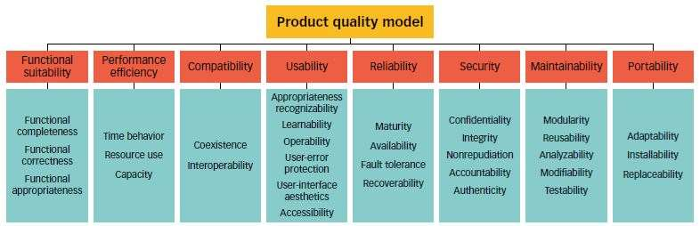

Software Quality shows how good and reliable a product is. To convey an associate degree example, think about functionally correct software. It performs all functions as laid out in the SRS document. But, it has an associate degree virtually unusable program. even though it should be functionally correct, we tend not to think about it to be a high-quality product.
Another example is also that of a product that will have everything that the users need but has an associate degree virtually incomprehensible and not maintainable code. Therefore, the normal construct of quality as “fitness of purpose” for code merchandise isn’t satisfactory.

Factors of Software Quality
The modern read of high-quality associates with software many quality factors like the following:

- Portability: A software is claimed to be transportable, if it may be simply created to figure in several package environments, in several machines, with alternative code merchandise, etc.
- Usability: A software has smart usability if completely different classes of users (i.e. knowledgeable and novice users) will simply invoke the functions of the merchandise.
- Reusability: A software has smart reusability if completely different modules of the merchandise will simply be reused to develop new merchandise.
- Correctness: Software is correct if completely different needs as laid out in the SRS document are properly enforced.
- Maintainability: A software is reparable, if errors may be simply corrected as and once they show up, new functions may be simply added to the merchandise, and therefore the functionalities of the merchandise may be simply changed, etc
- Reliability: Software is more reliable if it has fewer failures. Since software engineers do not deliberately plan for their software to fail, reliability depends on the number and type of mistakes they make. Designers can improve reliability by ensuring the software is easy to implement and change, by testing it thoroughly, and also by ensuring that if failures occur, the system can handle them or can recover easily.
- Efficiency. The more efficient software is, the less it uses of CPU-time, memory, disk space, network bandwidth, and other resources. This is important to customers in order to reduce their costs of running the software, although with today’s powerful computers, CPU time, memory and disk usage are less of a concern than in years gone by.

Software Quality Management System
Software Quality Management System contains the methods that are used by the authorities to develop products having the desired quality.
Some of the methods are:
- Managerial Structure: Quality System is responsible for managing the structure as a whole. Every Organization has a managerial structure.
- Individual Responsibilities: Each individual present in the organization must have some responsibilities that should be reviewed by the top management and each individual present in the system must take this seriously.
- Quality System Activities: The activities which each quality system must have been
  - Project Auditing.
  - Review of the quality system.
  - It helps in the development of methods and guidelines.

Evolution of Quality Management System
Quality Systems are basically evolved over the past some years. The evolution of a Quality Management System is a four-step process.
- Inception: Product inspection task provided an instrument for quality control (QC).
- Quality Control: The main task of quality control is to detect defective devices, and it also helps in finding the cause that leads to the defect. It also helps in the correction of bugs.
- Quality Assurance: Quality Assurance helps an organization in making good quality products. It also helps in improving the quality of the product by passing the products through security checks.
- Total Quality Management (TQM): Total Quality Management(TQM) checks and assures that all the procedures must be continuously improved regularly through process measurements.

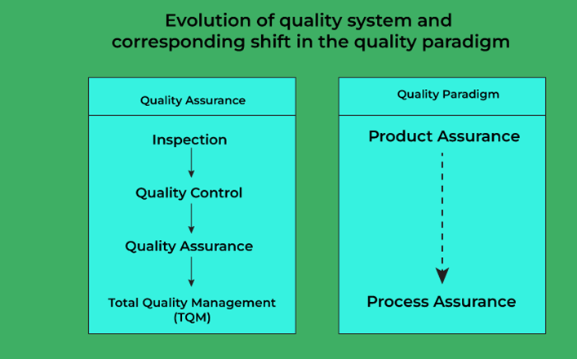

Objectives:
The objectives of software quality can be categorized into several key areas that aim to ensure the final product meets the desired standards and fulfills user requirements. Here are some of the primary objectives:
- User Satisfaction: Ensuring that the software meets the needs and expectations of users, providing a good user experience and usability.
- Reliability: The software should perform consistently under expected conditions, with a low rate of failure. This includes handling errors gracefully.
- Functionality: The software must perform its intended functions correctly and efficiently, providing all required features and capabilities.
- Performance: The software should respond quickly and efficiently, minimizing resource usage and ensuring it can handle expected load and performance requirements.
- Maintainability: The software should be easy to maintain, update, and modify. This includes having clear and manageable code, thorough documentation, and modular design.
- Portability: The software should be adaptable to different environments and platforms without requiring extensive rework.
- Security: Ensuring the software is resistant to threats and vulnerabilities, protecting data and maintaining user privacy.
- Compliance: Adhering to relevant industry standards, regulations, and best practices, ensuring that the software meets legal and ethical requirements.
- Scalability: The software should be able to grow and accommodate increasing amounts of work or users without compromising performance.
- Testability: The design of the software should facilitate testing, allowing for easy detection of defects and verification of functionality.
McCall’s Software Quality Model:
McCall’s Software Quality Model was introduced in 1977. This model is incorporated with many attributes, termed software factors, which influence software. The model distinguishes between two levels of quality attributes:
- Quality Factors
- Quality Criteria

Quality Factors: The higher-level quality attributes that can be accessed directly are called quality factors. These attributes are external. The attributes at this level are given more importance by the users and managers.

Quality Criteria: The lower or second-level quality attributes that can be accessed either subjectively or objectively are called Quality Criteria. These attributes are internal. Each quality factor has many second-level quality attributes or quality criteria.

Example: The usability quality factor is divided into operability, training, communicativeness, input/output volume, and input/output rate. This model classifies all software requirements into 11 software quality factors. The 11 factors are organized into three product quality factors: Product Operation, Product Revision, and Product Transition.

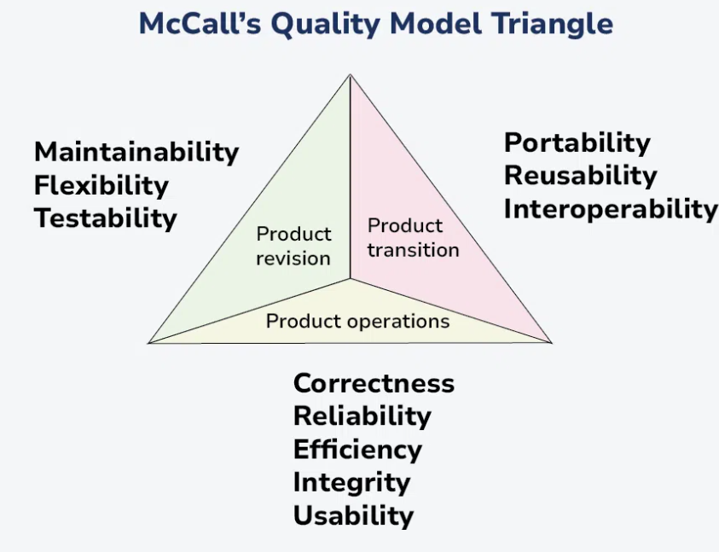

Factors of Product Quality
Below are the factors of Product Quality, that are discussed in detail.
- Product Operation
- Product Revision
- Product Transition

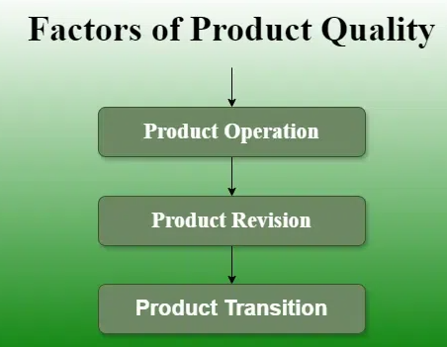

Product Operation Factors
These factors describe how well the software performs when users operate it.

1. Correctness
Correctness measures whether the software satisfies its specifications and user requirements.
Example: A fee-management system calculates tuition fees and penalties according to the defined rules.

2. Reliability
Reliability measures the ability of software to perform its required functions under specified conditions for a specified period.
Example: An online banking system processes transactions consistently without frequent failures.

3. Efficiency
Efficiency refers to how effectively software uses computing resources, such as CPU time, memory, storage, and network bandwidth.
Example: A student database retrieves a record quickly without consuming excessive memory.

4. Integrity
Integrity refers to the software's ability to protect programs and data against unauthorized access or modification.
Example: Only authorized administrators can change students' personal records.

5. Usability
Usability refers to the effort required to learn, operate, and understand the software.
Example: A student can easily locate the attendance and examination-result sections of a portal.

Product Revision Factors
These factors describe how easily software can be corrected, tested, or modified.

6. Maintainability
Maintainability is the ease with which software defects can be located and corrected.
Example: A developer can fix an incorrect attendance calculation by modifying one clearly structured function.

7. Flexibility
Flexibility is the ease with which software can be modified to accommodate new requirements.
Example: A college application can support a new grading scheme without requiring a complete redesign.

8. Testability
Testability is the ease with which software can be tested to verify its functionality and identify defects.
Example: A fee-calculation function accepts defined inputs and returns outputs that can be checked using test cases.

Product Transition Factors
These factors describe how easily software can be transferred, reused, or integrated with other systems.

9. Portability
Portability is the ease with which software can be transferred from one environment to another.
Example: An application can be moved from one supported operating system to another with limited modifications.

10. Reusability
Reusability is the ability to use software components in other applications or projects.
Example: A login module developed for a college portal is reused in a library management application.

11. Interoperability
Interoperability is the ability of software to interact and exchange information with other systems.
Example: A college management system exchanges student data with an external examination platform through an API.

Summary of McCall’s model
Category | Quality factors | Main question
Product operation | Correctness, reliability, efficiency, integrity, usability | Does the software work well?
Product revision | Maintainability, flexibility, testability | Can the software be changed and tested easily?
Product transition | Portability, reusability, interoperability | Can the software move, be reused, and communicate with other systems?

HP Software Quality Model
The HP software quality model is presented in different ways in software engineering references. A commonly taught HP quality-factor set emphasizes five attributes:
- Functionality
- Usability
- Reliability
- Performance
- Serviceability
The exact terminology and grouping can differ between textbooks, so follow the specific HP model prescribed in your syllabus if it uses a different diagram or list.

Explanation of HP quality attributes
1. Functionality
Functionality refers to the features and services provided by the software to satisfy user requirements.
Example: A library management system supports book searching, issuing, returning, and fine calculation.
2. Usability
Usability refers to how easily users can learn and operate the software.
Example: A college portal provides clear navigation and understandable error messages.
3. Reliability
Reliability refers to the software's ability to operate consistently without failure under specified conditions.
Example: An online examination system saves student answers correctly throughout an examination.
4. Performance
Performance refers to the responsiveness and resource efficiency of the application under a specified workload.
Example: A results portal loads a student's marks within two seconds under the required load conditions.
5. Serviceability
Serviceability refers to the ease with which software can be diagnosed, maintained, repaired, and supported.
Example: Clear logs and diagnostic tools help administrators identify and correct a database connection failure.

Comparison: McCall’s model and the commonly taught HP model
Basis | McCall’s model | Commonly taught HP factor set
Number of factors | 11 | 5 in the version described here
Main organization | Three categories | Broad product-quality attributes
Categories | Operation, revision, transition | Functionality, usability, reliability, performance, serviceability
Main purpose | Evaluate multiple dimensions of software quality | Emphasize key functional and operational qualities
Example | Explicitly includes portability and interoperability | Emphasizes performance and serviceability
Exam note: Do not automatically treat the HP model as identical to McCall’s model. If your textbook provides a different HP quality model, use that textbook's exact factors and classification.

Software Deployment

Software deployment is the process of making a software application available for use. It encompasses a series of activities, from preparing the software for release to installing and configuring it on target systems. The primary objective is to transition the software from the development environment to a production environment while ensuring its functionality and performance meet user expectations.

Importance of Software Deployment:
Efficient software deployment is vital for delivering new features, fixing bugs, and implementing improvements promptly. It facilitates a smooth transition from the development phase to production, reducing downtime and disruptions. A well-executed deployment also contributes to system reliability, security, and overall user satisfaction.
- Fixing bugs and Enhancing Performance: The release of updates, bug fixes, and performance enhancements is made possible by deployment. It guarantees that consumers are utilizing reliable and effective software versions.
- Competitiveness and Time-to-Market: Time-to-market is shortened by quick and effective deployment, which helps businesses remain competitive in ever-changing markets. Having the capacity to release updates rapidly can give you a competitive edge.
- User Experience and Satisfaction: Updates that are regularly released guarantee that consumers receive the newest enhancements, which raises user happiness. Promptly implementing deployment in response to customer input improves the overall user experience.
- Feedback System for Ongoing Improvement: Frequent deployment establishes a feedback loop that offers insightful information about how consumers engage with the programme. This information can be utilized to guide future development and deployment strategies and promote continual improvement.
- Optimizing Resources and Cutting Costs: Optimizing resources and cutting costs are two benefits of efficient deployment techniques. Processes for deployment can be automated to save manual labor, cut down on mistakes, and guarantee consistent outcomes in all situations.

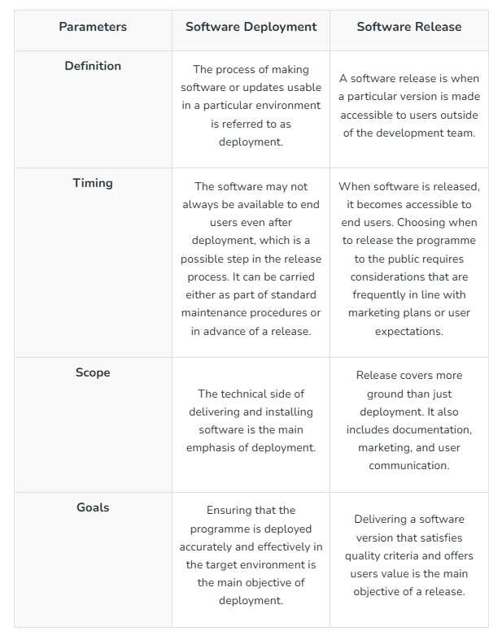

Software Deployment Methodologies:
Several methodologies guide software deployment:
- Continuous Deployment: Involves automatically releasing every code change to production, ensuring a rapid and continuous delivery pipeline.
- Continuous Delivery: Focuses on maintaining a state where the software is always in a deployable condition, even if not deployed immediately.
- Staged Deployment: Releases the software in phases, starting with a small user group before expanding to a broader audience. This helps identify and address issues progressively.
- Blue-Green Deployment: Involves maintaining two identical production environments (blue and green), with only one actively serving users at a time. This minimizes downtime during updates by switching between environments.

Software Deployment Processes:
- Planning: Define deployment goals, assess potential risks, and create a detailed deployment plan outlining tasks and responsibilities.
- Build: Compile the code and create the executable software package. This involves generating artifacts, binaries, or installers.
- Testing: Conduct thorough testing, including unit, integration, and system testing, to identify and fix any issues before moving to the next stage.
- Staging: Deploy the software in a controlled staging environment that closely mirrors the production environment. This step allows for further testing and validation.
- Deployment: Distribute the software to the target production systems. This can involve manual or automated processes, depending on the scale and complexity of the deployment.
- Monitoring: Continuously monitor the deployed software to detect and address any issues promptly. Monitoring helps ensure that the software operates as expected in the production environment.

Deployment planning:

1. Deployment Strategy
- Big Bang Deployment: All components are deployed at once. Suitable for small projects but risky for larger applications.
- Phased Deployment: Components are deployed in phases, allowing for gradual integration and testing. This reduces risk and can improve user acceptance.
- Canary Releases: A small subset of users gets the new version first, allowing for monitoring and quick rollback if issues arise.
- Blue-Green Deployment: Two identical environments (blue and green) are maintained, allowing for easy switching between versions with minimal downtime.

2. Environment Preparation
- Production Environment: Ensure that the production environment (hardware, software, and network configurations) is ready and mirrors the testing environment.
- Testing Environment: Conduct thorough testing in a pre-production environment that simulates the production environment as closely as possible.

3. Deployment Automation
- Scripts and Tools: Use automation tools and scripts to facilitate the deployment process, reducing manual effort and errors.
- CI/CD Pipelines: Implement Continuous Integration and Continuous Deployment practices to automate the testing and deployment of code changes.

4. Backup and Rollback Plans
- Data Backup: Ensure that data is backed up before deployment to prevent data loss.
- Rollback Procedures: Establish clear procedures for rolling back to the previous version if deployment fails or issues arise.

5. Monitoring and Logging
- Performance Monitoring: Set up monitoring tools to track the performance and health of the application post-deployment.
- Logging: Implement logging to capture errors and usage metrics, helping identify and diagnose issues quickly.

6. User Communication and Training
- Stakeholder Communication: Inform stakeholders about the deployment schedule, potential impacts, and any required actions from them.
- User Training: Provide training materials or sessions for users to familiarize them with new features or changes.

7. Post-Deployment Review
- Evaluation: After deployment, evaluate the process, gathering feedback from users and stakeholders.
- Continuous Improvement: Identify lessons learned and areas for improvement for future deployments.

8. Documentation
- Deployment Documentation: Maintain detailed documentation of the deployment process, configurations, and any issues encountered, which can be useful for future reference.

Deployment rollback:
Deployment rollback is a process that restores a system to a previous state when a deployment fails or causes issues. It's an essential part of any system deployment strategy because it can help minimize downtime, avoid data loss, and preserve user trust
Deployment rollback in software engineering refers to the process of reverting a software application to a previous stable version after a deployment has failed or introduced critical issues. Rollbacks are essential for maintaining system reliability and minimizing downtime. Here’s a detailed look at the rollback process, its importance, strategies, and best practices:
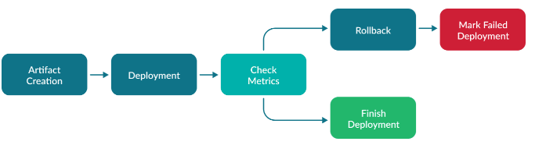

Importance of Rollback
- Minimizing Downtime: If a new deployment causes significant issues, rolling back allows the application to return to a working state quickly, reducing disruption for users.
- Risk Mitigation: Rollbacks provide a safety net against deployment failures, allowing teams to respond effectively to unexpected problems.
- User Satisfaction: Ensuring that users experience minimal interruptions contributes to overall satisfaction with the software.

Rollback Strategies
- Version Control:
  - Maintain a history of all versions in a version control system (e.g., Git). This allows teams to easily revert to a previous version of the codebase.
- Database Migration Management:
  - Use migration tools to manage database changes. If a deployment fails, having the ability to roll back database changes (e.g., using Flyway or Liquibase) is crucial.
- Canary Releases:
  - By deploying updates to a small subset of users first, teams can monitor performance. If issues arise, they can easily revert the changes for just the canary group.
- Blue-Green Deployment:
  - In a blue-green deployment setup, two identical environments (blue and green) are maintained. The new version is deployed to the inactive environment, and if issues occur, traffic can be switched back to the stable version without downtime.
- Feature Toggles:
  - Implementing feature flags allows teams to turn features on or off without rolling back the entire application. This provides flexibility in managing new features.

Rollback Process
- Detection of Issues:
  - Monitor the application for errors, performance issues, or user feedback that indicates a deployment failure.
- Decision to Rollback:
  - Evaluate the severity of the issues and decide whether a rollback is necessary. Consider potential impacts and the urgency of the rollback.
- Executing the Rollback:
  - Depending on the rollback strategy:
    - Version Control: Revert the codebase to the last stable commit and redeploy.
    - Database Migration: Run scripts to revert database changes.
    - Feature Toggles: Disable the problematic features.
- Testing:
  - After rolling back, conduct tests to ensure that the previous version operates correctly and that the rollback was successful.
- Communication:
  - Inform stakeholders and users about the rollback, the reasons for it, and any expected impacts.
- Post-Rollback Review:
  - Conduct a retrospective to analyze the deployment that led to the rollback. Identify what went wrong and how to prevent similar issues in future deployments.

Best Practices for Rollback
- Plan for Rollback: Incorporate rollback procedures into the deployment plan to ensure readiness if issues arise.
- Automate Rollback Procedures: Automating rollback processes can reduce the time taken to revert to a stable state.
- Document Rollback Procedures: Maintain clear documentation on how to perform rollbacks for different scenarios to assist the team during critical moments.
- Testing: Regularly test rollback procedures as part of the deployment pipeline to ensure they work as expected.
- Maintain Backups: Always back up data and configurations before deploying changes to ensure they can be restored easily.

